Dr Jeff Fidler & Dr Steve Karner
194 Thorold Rd.
Welland Ont.
L3C 6M7
905-735-7410
www.wellandanimalhosp.com
wah@cogeco.net

Update on Ticks

Ticks are becoming an ever increasing problem in our area. Because of the increased prevalence of ticks we thought we would provide you with some information about ticks and how you can better protect your pet from these parasites and the harmful tick borne diseases that they can spread.

With ticks come the potential for tick borne diseases namely; Lyme disease, Anaplasmosis, and Ehrlichiosis.
 | Lyme disease | Anaplasmosis | Ehrlichiosis
Cause | 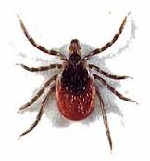 |  | 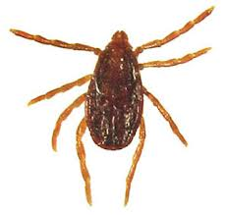
 | Deer Tick | Deer tick | Brown Dog Tick
Symptoms | - Lameness  - Fever  - Swollen Joints  - Kidney Failure  - Not himself/herself  - Anorexia | - Lack of energy  - High fever  - Swollen Joints  - Anorexia  - Vomiting  - Diarrhea | - Loss of Appetite  - Fever  - Painful Joints  - Bloody Nose  - Pale Gums
Disease Progression | Damaged joints, fatal kidney disease. | Very low numbers of platelets and white blood cells, chronic joint pain, neurological signs (rare) | Permanent blindness, autoimmune diseases, bleeding complications, death.
Diagnosis | In Hospital 4DX test (combined with Heartworm Screening)
Treatment | Antibiotics - Doxycycline
Prognosis | If caught and treated early the prognosis is usually good.
Vaccine Available | Yes | No | No
Other Prevention | Daily Tick Inspection & Removal, and the use of Advantix or Preventic Collar

Here is an excellent website to find out more about ticks and the diseases they carry.
www.dogsandticks.com
Here is link to a good video on the life cycle of the Deer tick and its relationship to Lyme disease.
http://www.youtube.com/watch?v=D7skqdqWYTI
Our Recommendations;
- All at risk dogs (previous history of having ticks, run through long grass or wooded areas) should be placed on a tick preventative (Advantix or Preventic Collars), from early spring to the fall. (N.B. there is no tick preventative product that is safe to use on cats.)

- Daily tick inspection & removal.

- Consider Lyme Vaccination for those dogs at significant risk. I.e. previous history of Lyme disease, significant tick exposure or visit high risk areas (Wainfleet Marsh).

If you have any questions or concerns please give us a call.
Sincerely,
Welland Animal Hospital.

