Bill of Material Creation – MCAD Tips
Pro/REPORT is a powerful component of Creo Parametric drawing mode which allows highly customizable tables to be automatically created and added to drawings. It does this through the use of repeat regions which are areas of the table the software automatically populates and special report parameters that are inserted into the repeat regions. While Pro/REPORT is primarily used for the creation of BOM tables, it can also be used to create tabulated drawings of family table parts. This document describes its use for BOM generation.
Consider the drawing shown in Figure 1 below. It contains a single view of a 3 cylinder double acting steam engine along with a simple table created with 4 columns and 2 rows. The assembly components contain two parameters; PART_NO and DESCRIPTION, that we wish to have shown in the table.
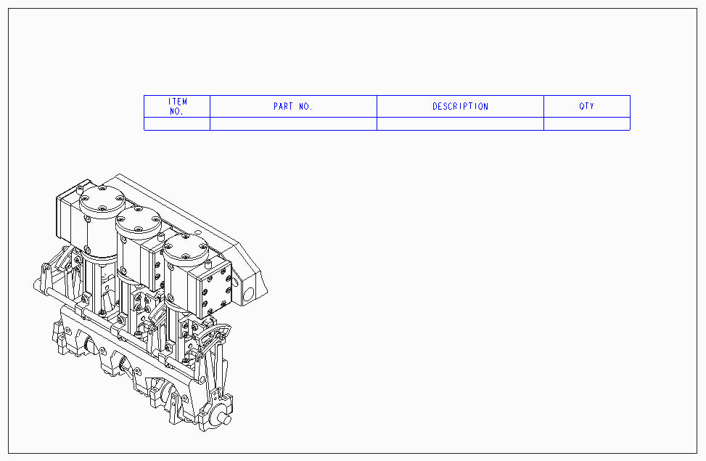
Figure 1
The next step in the process is to designate an area of the table that is to be the repeat region. In our example above the entire bottom row will be used as the repeat region. Using the Repeat Region functionality under the drawings Table Tab, the entire lower row is added as a simple repeat region. After the repeat region is selected, its Attributes are set to No Duplicates, Flat and Bln By Comp. Using “Switch Syms” the repeat region shows as in Figure 2.
Figure 2
Once the Repeat Region is created, we no longer add simple note text to the empty cells but instead use special Report Symbol Parameters. While there are a large number of available parameters the most commonly used are:
rpt.index - Item number
asm.mbr.name - Component Name
asm.mbr.user_def - Show a value of a parameter in the table
rpt.qty - Calculated quantity

Figure 3 below shows our table after being populated with rpt.index, asm.mbr.PART_NO, and rpt.qty.
Figure 3
Using the Switch Symbols/Update Table icon picks the table will now appear as in Figure 4.
Figure 4
Note that the above table only contains a single row showing a quantity of 77 of Item 1 with a corresponding part number of “-“. The reason only one row is shown is Pro/REPORT reports on unique values of the report parameters asked for. All of the components in this assembly have a PART_NO parameter set to “-“. If we now start assigning real part numbers to the components PART_NO parameter and regenerate the table we might get a table shown in Figure 5.

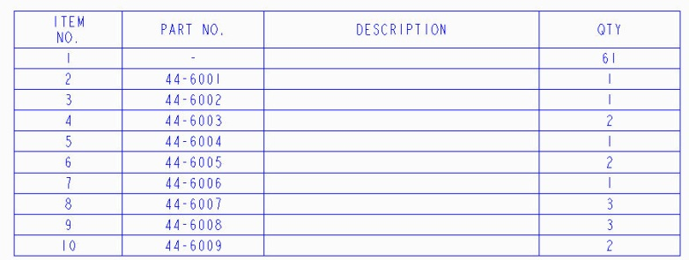
Figure 5
In the above table, 9 components have had their PART_NO parameter set to a value other than “-“ so the table now shows unique values of the part number parameter leaving 61 components whose part number parameter is still “-“.
We will now add the DESCRIPTION parameter to the table as shown in Figure 6 below.
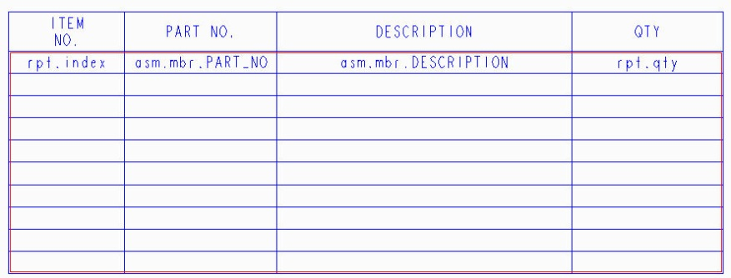
Figure 6
Adjusting column widths and updating the table now gives us the table shown in Figure 7. While not all the components have been given a unique part number, they each do have a DESCRIPTION parameter that has been assigned to them. Pro/REPORT then shows the correct quantities of the unique values of the PART_NO and DESCRIPTION parameters.
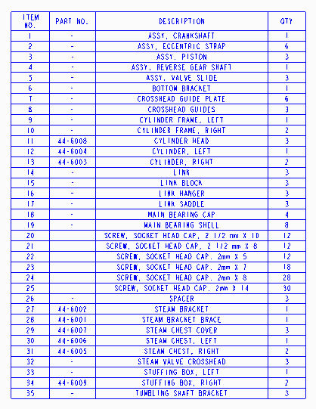
Figure 7
Notice that the table in Figure 7 shows 35 unique items. To make sure we have all unique components shown we can temporarily add a column to the table containing “asm.mbr.name” which will display the component part name to the table. After updating, the table appears as in Figure 8. Notice the new table below also contains 35 items. This is a simple check to ensure the unique combination of the PART_NO and DESCRIPTION parameters results in a single row for each assembly component.
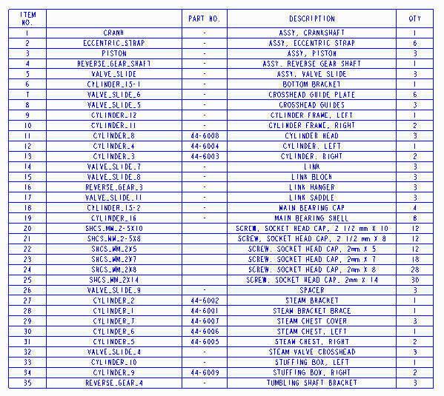
Figure 8
Removing the extra column and assigning values to the PART_NO parameter to all the components and updating the table will result in the table shown in Figure 9 below. The table below has also been sorted using the Part No. parameter.
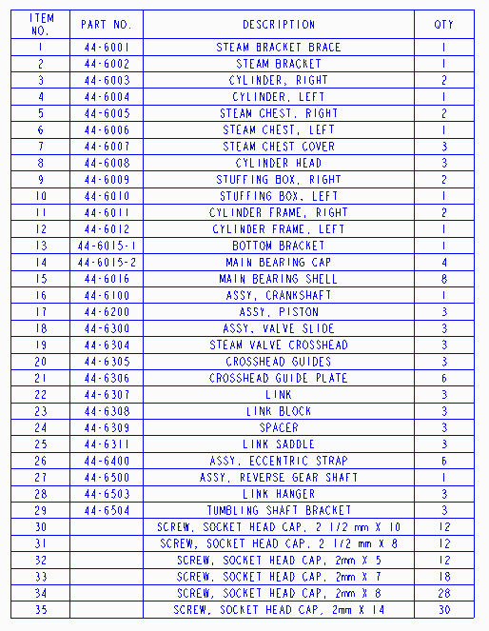
Figure 9
While this example demonstrates the creation of a simple BOM table, the repeat regions can be more complex. Using a repeat region setup shown in Figure 10 results in the BOM table shown in Figure 11.
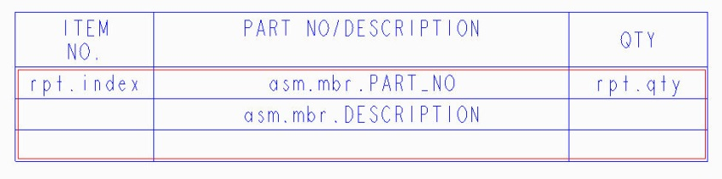
Figure 10
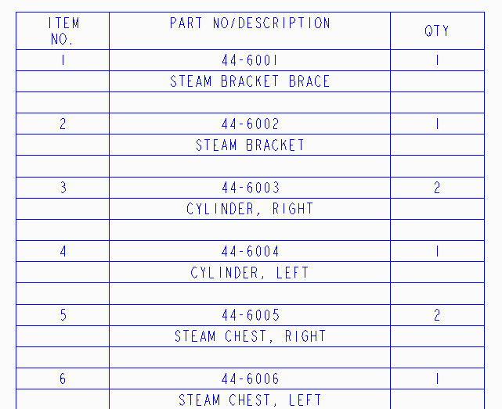
Figure 11
Notice that all three rows of the repeat region are being duplicated for each found item.
The Pro/REPORT functionality of drawing mode is a powerful, simple to use report generator that can be used to generate Bill of Materials tables for drawings. While this document demonstrates the ease by which tables can be created, it just touched on the basic Repeat Region functionality. I encourage readers to learn more about this powerful capability either by attending a “Detail Drawing using Creo Parametric 2” training class or by using the on-line help to learn more about how the power of Repeat Regions can be used to create the tables you need.
If you are interested in training classes or any other info, be sure to contact Rob Romanoski at 3 HTi at (610) 590-1089 or rromanoski@3hti.com. I hope you find this information helpful!
- Bruce Bodnyk
Bruce Bodnyk is a Mechanical Engineering Services Consultant and Instructor for MCAD software. He has over 30 years experience working with various CAD and PLM systems.

